
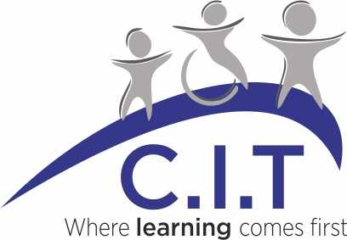

BINGHAM PRIMARY SCHOOL
Disability Equality Scheme and Accessibility Plan

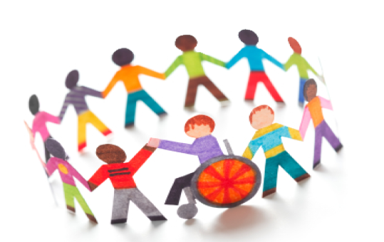

This document has been created by the Governors of our school to ensure that we are committed to providing an environment where children have fair and equal access to Bingham Primary School
Reviewed: November 2025
Date of next review: November 2026

Contents
Section 1 Introduction
Disability Discrimination Act
Disability Equality Duty
Section 2 Definitions and Duties
Section 3 Vision and Values
Section 4 Accessibility
Section 5 Action Plan
Section 1 Introduction

Disability Discrimination Act (DDA)

Since September 2002, the Governing Body has had three key duties towards disabled pupils, under Part 4 of the DDA:
- not to treat disabled pupils less favourably for a reason related to their disability
- to make reasonable adjustments for disabled pupils, so that they are not at a substantial disadvantage
- to plan to increase access to education for disabled pupils.

This plan sets out the proposals of the Governing Body to:
- increase the extent to which disabled pupils can participate in the school curriculum
- improve the environment of the school so that pupils with a disability can take full advantage of the education offered
- improve the delivery of information to disabled pupils.

The school’s Accessibility Plan will be reviewed and reported on annually at a Governors’ meeting.

Disability Equality Duty

The DDA 1995 has been amended by the DDA 2005 so that it now places on schools to have due regard to the need to:
- promote equality of opportunity between disabled persons and other persons
- eliminate discrimination that is unlawful under the Act
- eliminate harassment of disabled persons that is related to their disabilities
- promote positive attitudes towards disabled persons
- encourage participation by disabled persons in public life
- take steps to take account of disabled person’s disabilities, even where that involves treating disabled persons more favourably than other persons.

Although the DDA was replaced by the 2010 Equality Act, the Disability Equality Duty in the Disability Discrimination Act still continues to apply. The specific requirement is for public authorities to have a Disability Equality Scheme. This requirement for schools came into force on December 2007 for Primary schools.

Section 2 Definitions and Duties

Disability Discrimination Act

The DDA 1995 defines a disabled person as someone who has: “a physical or mental impairment which has a substantial and long term adverse effect on his or her ability to carry out normal day-to-day activities”.

The definition can include a wide range of impairments, including dyslexia, autism, speech and language impairments, attention deficit hyperactivity disorder (ADHD). An impairment does not in itself mean that a pupil is disabled. It is the effect on the pupil’s ability to carry out normal day-to-day activities that has to be considered.

The test whether an impairment affects normal day-to-day activity is whether it affects one or more of the following:
- Mobility
- Manual dexterity
- Physical coordination
- Continence
- Ability to lift, carry or otherwise move everyday objects
- Speech, hearing or eyesight
- Memory or ability to concentrate, learn or understand
- Perception of risk of physical danger.

The definition in the DDA is broad. It includes more pupils than many think. There is a significant overlap with pupils with special educational needs (SENs), though the definition of SENs does not cover all disabled children. For example, pupils with medical conditions, disfigurements and other impairments may count as disabled but may not have SENs.

The existence of an impairment or condition does not depend on an official diagnosis if the impairment is long-term (12 months or more) and has a substantial adverse effect, it falls within the terms of the DDA whether there has been an official diagnosis or not.

The Duties in Part 4
It is unlawful for schools to discriminate against disabled pupils. A school discriminates if:
- It treats a disabled pupil or prospective pupil less favourably than another for a reason related to their disability and without justification
- It fails, without justification, to take reasonable steps to avoid placing disabled pupils at a substantial disadvantage. This duty is often known as the “reasonable adjustments” duty.

Disability Equality Duty

The changes to the DDA 1995 brought about by the DDA 2005 have brought about a change in focus from a reactive to a proactive attitude to disability. The Disability Equality Duty includes both general and specific duties. The Codes of Practice for public authorities and schools must have “due regard” to the Codes.

“Due Regard” comprises two linked elements: proportionality and relevance. In all their decisions and functions schools should give due weight to the need to promote disability equality in proportion to its relevance.

“The General Duty” requires schools to consider the six issues (Section 1) in all actions we take. This includes activities inside and out of the classroom. The general duty will build on existing responsibilities including the duties to make reasonable adjustments and to plan strategically to increase access to the school over time.

“The Specific Duty” regulations require schools to produce a Disability Equality Scheme (DES). We are combining the DES with the Accessibility Plan.
These are our specific duties:
- to produce a DES demonstrating how we will fulfil general and specific duties
- we will involve disabled people in the development of the Scheme
- to report on the Action Plan.

Section 3 Vision and Values
The Governors and staff of Bingham School will ensure that the school will be a community based learning environment, involving pupils, parents, families and the local community in the delivery of an excellent curriculum that is relevant to all its members. We will build learners for the future and equip them with skills so that they have:
- a secure knowledge of their own learning styles and needs
- an ability to take ownership of their learning
- identify ways of reaching their own targets, goals and aspiration
- have an understanding of how to ensure their own physical and emotional health and support others around them in doing the same
- an understanding of how being a member of a successful, collaborative community can enhance chances of success.

We will utilise technologies to support the learning and teaching processes, striving to be innovative.

We will be a sustainable school.

At Bingham School we seek to provide an education that is underpinned by a sense of community, an understanding of local and global diversity and compassion in our behaviour toward each other.
We consider ourselves a community in which individuals’ needs are recognised and all members’ talents and aptitudes fostered. The care for each child is central to our aims and provision.

We are committed to a policy of equal opportunities for all; children, parents, staff and visitors.

We will not discriminate against anyone on grounds of race, ethnic origin, gender, sexual orientation, religious beliefs or disabilities.

We welcome the contribution equal opportunities makes to the education and learning of all members of our school through:-
- developing and reinforcing the views and rights of the individual and groups who have different beliefs
- preparing to be active members of a community, understanding the value of citizenship and developing an awareness of societies in other parts of Britain and across the world
- a school curriculum that is planned to include issue-based work.

We undertake:-
- to promote the self esteem and emotional and social development of each pupil
- to ensure that girls and boys have a full entitlement to a broad and balanced curriculum and they become well rounded learners
- to work closely with our pupils to identify their learning styles and preferred areas of intelligence
- to provide, through the behaviour of staff, towards each other, pupils, parents and visitors, an example that will encourage all members of our school community to be conscious of the importance of equal opportunities and respect for others
- to respect the cultural and ethnic diversity of pupils, parents, staff and visitors
- to enrich the pupils’ education with experiences that will further their understanding of other cultures and celebrate difference
- to develop our pupils’ debating and reasoning skills so that they respect and listen to other points of view
- to enable high quality learning to take place through studying other religions as set down in the Nottinghamshire Agreed Syllabus
- to make full use of opportunities within the life of the school to increase religious understanding and tolerance and forge links with the wider community.

We will strive to overcome barriers to learning and assessment for individuals and groups of pupils.

We aim to identify and remove barriers to disabled pupils in every area of school life

Section 4 - Accessibility (updated Nov 2023)

The Governors and staff at Bingham School will have regard to the implications of the DDA and embed good practice across all aspects of school life.

Actions Completed:

- We aim to ask about any disability of health condition in early communication with new parents/carers as part of our school admission procedure.
- Pupils with disability or health conditions and their needs are made known to all staff.
- Internal emergency signage and escape routes are clearly marked.
- Learning support assistants work with identified children
- Out of school activities (including residentials) breakfast and after-school clubs are planned to ensure reasonable adjustments are made to enable the participation of all pupils.
- The SENDCo has dedicated release time.
- We consult with experts and external agencies when new situations regarding pupils with disabilities are experienced.
- Visual timetables using Widget symbols are used in every classroom.

Ongoing actions;

- Lesson observations by the headteacher, SENDCo, subject leaders and governors include aspects of inclusion in teaching and learning.
- We are developing and apply a range of formats to meet differing needs. Visual signs are used in appropriate place for those who need visual cues to help them. We are aware of services to produce alternative formats if necessary and where to seek support and help.
- We use our assessment system in school to monitor progress as a school and the progress of those pupils with a disability to ensure that we are adding value for each individual. Identified Governors are to support the Headteacher in monitoring the assessment systems, safeguarding and all priorities in the School Development Plan.
- The School Council has been involved in identifying areas of the school that need improvement and were involved in the plans to change the toilets and also to create two more learning spaces.
- The Bronze Ambassadors ensure they adapt their games to be fully inclusive of all pupils who choose to engage in playground games.
- Adaptation of the curriculum to meet the needs of individual pupils through pastoral support, timetable adaptations, individual programmes, ELSA, Lego therapy, SALT support, use of scaffolds, equipment, effective use of resources including sloping boards, reader pens, talking cans, pencil grips, ear defenders, wobble cushions, reading rulers, colour overlays, manipulatives and visual and sensory aids.

Section 5 - Action Plan

- School Council will be involved in identifying areas of the school that need improvement and will be instrumental in creating our development for the next academic year.

- To ensure that we are able to consider and accommodate adaptation to areas of our school at the request of a parent or the Local Authority to ensure that they have, wherever possible, access to Bingham Primary School.

- Ensure effective communication and engagement with parents through termly meetings, class dojo, school website, LSP reviews, library sessions, curriculum workshops, special event days and celebration assemblies.

- Training for staff on increasing access to the curriculum for all pupils with epipen and epilepsy trainings, training and support from external sources including ASKSALL, physiotherapists, SALT, WTT, improved access to training and CPD through NASEN modules (https://nasen.org.uk/)

.

